**The Cellular Concept**

Table of Contents

3.2 Frequency Reuse 4

3.3 Channel Assignment Strategies 7

Fixed Channel Allocation 7

Dynamic Channel Allocation 7

3.4 Handoff Strategies 8

Handoff Thresholds 9

Guard Channels 9

Umbrella Cells 9

Cell Dragging 10

Terminology 11

3.5 Interference and System Capacity 12

Co-channel Interference 12

3.6 Trunking and Grade of Service 16

Grade of Service 17

Terminologies 18

Equations 18

3.7 Improving Coverage and Capacity 20

Cell Splitting 20

Sectoring 21

Repeaters 21

This chapter is from Chapter 3 of the book ‘Wireless Communications - Principles and Practice - T. Rappaport (2nd Edition)’.

## 3.2 Frequency Reuse

Under the cellular concept, the total coverage area is subdivided into smaller geographical areas, called cells. The base station for that cell is allocated a number of radio channels to use in that cell. Those radio channels can then be reused in other cells. Essentially, a certain frequency being used in one area does not prevent us from using that same frequency for other data in a different area, given that the areas are not so close as to cause problems.

The signal for one base station should only work within its own cell. Since antennas are omnidirectional, one would imagine that the cells are circular. However, circles would overlap in some areas and leave dead spots in other areas, both of which would cause problems. Thus, hexagons are used, since they closely approximate circles and also because it has been found that fewer hexagons are needed to cover a region than say squares or triangles.

We do need to be careful about reusing frequencies though. Adjacent cells should have channels that are completely different from one another. Cells that use the same frequencies, which are called co-channel cells, are placed far enough apart that there are no issues.



The $N$ cells which collectively use the complete set of frequencies is called a cluster. In the above image, $A$, $B$, $C$, $D$, $E$, $F$ and $G$ form a cluster. The cluster appears three times in this image. This is called a $7$-cell reuse pattern. Smaller clusters mean more reuse, but higher chances of interference. Larger clusters ensure less interference, but less reuse.

The value of $N$ is given by the following formula:

$$N=i^{2}+ij+j^{2}$$

Here, $i$ is the number of cells that we need to travel horizontally and $j$ is the number of cells we need to travel vertically to get from one co-channel to another. In the example above, $i=2$ (going from the left-most $A$ over $C$ and $E$) and $j=1$ (from $E$ to the top-most $A$). Thus, $N=7$.

Example

a) A $30MHz$ spectrum is allocated to a wireless system which uses two $25kHz$ simplex channels to provide full duplex voice and control channels. Compute the number of channels available per cell if the system uses $7$-cell reuse.

Channel bandwidth $=25×2=50kHZ$

Total channels $=\frac{30000}{50}=600$

Channels per cell $=\frac{600}{7}≈85$

b) If $1MHz$ of the allocated spectrum is dedicated to control channels, determine an equitable distribution of control channels and voice channels in each cell of that system.

$\frac{1000}{50}=20$ control channels exist in the $600$ channels.

$$\frac{600-20}{7}=82.85$$

Thus, we can make an approximately equal distribution by giving $4$ of the cells in each cluster $3$ control channels and $82$ voice channels and $3$ of the cells in each cluster $2$ control channels and $83$ voice channels. The channels cannot be completely equally divided, so this approximation is made. A slightly different answer would also be acceptable.

## 3.3 Channel Assignment Strategies

### Fixed Channel Allocation

Under fixed channel allocation (FCA), a fixed number of channels are permanently allocated to each cell. If all the channels for a cell are occupied, any new call attempts are blocked.

### Dynamic Channel Allocation

Under dynamic channel allocation (DCA), channels are not permanently allocated to cells. There is essentially a pool of resources, and the central control allocates resources on demand. This means one cell can borrow channels from a neighbouring cell if it is under pressure. DCA is more commonly used.

## 3.4 Handoff Strategies

When a mobile phone moves into a different cell while a call is in progress, the Mobile Switching Centre (MSC), which is essentially the central control, automatically transfers the call to a new channel belonging to the new base station. This process is called a handoff or handover.

The base station (BTS) for a cell is constantly receiving a signal from every device it is serving. Using this, it gets the Radio Signal Strength Indications (RSSI) or Received Signal Strength Indications data. This data tells the BTS how strong the connection with a particular device is. If the connection becomes weak, it realizes that a handoff is required and requests one.

The RSSI method was used in the first generation of mobile networks (1G). In the second generation (2G), the mobile devices would assist the BTS by sending data about the signal strengths of nearby BTS towers so that their own BTS can decide which neighbouring BTS they need to handover the call to. This process was called Mobile Assisted Handoff (MAHO).

Handoffs are prioritized, even over new calls. This is because it would be more irritating for the end user to have an ongoing call dropped than to be unable to connect when making a new call.

### Handoff Thresholds

There is a minimum acceptable signal level that is required to maintain a call. Normally, this is between $-90dBm$ and $-100dBm$. The threshold at which a handoff is made is decided to be a little above this. The difference between the handoff threshold and the minimum acceptable signal threshold is $Δ$. If the value of $Δ$ is too large, unnecessary handoffs will be made, which will put stress on the system. If the value of $Δ$ is too small, then there will not be enough time to make the handoff between the point where the decision to make a handoff is made and when the signal becomes too weak to keep the call connected.

### Guard Channels

A fraction of the total available channels in a cell are reserved for handoff requests. These are called Guard Channels. The total carried traffic is reduced due to this, but it decreases the chances of ongoing calls being terminated, which would irritate users far more.

### Umbrella Cells

If there is an area where vehicles generally move at very high speeds, such as a highway, the vehicles will move from one cell to another very quickly, in a matter of seconds. This makes it very difficult for the MSC to perform the required handoffs. This is opposed to pedestrian users, for whom this problem is not applicable.

To deal with this problem, the concept of umbrella cells was introduced. Multiple BTSs with smaller coverage are used to deal with users that are not moving at high speeds. These cells are called microcells. Additionally, another BTS with a much larger coverage is also used, which creates an overlapping ‘umbrella’ cell. This BTS is used exclusively with users travelling at high speeds to prevent frequent handoffs from occurring.



To prevent the umbrella cell from interfering with the microcells, it is given a higher height as well as a different power.

### Cell Dragging

It is possible that a user moves physically away from one cell and closer to another, but the signal strength with the previous cell does not become so weak that a handoff is triggered. This situation is called cell dragging. It leads to a lot of interference, so it needs to be handled properly.

### Terminology

Base Transceiver Station (BTS) – This is the tower that covers a certain cell. Generally, it is omnidirectional and placed in the centre of the cell. However, it might also be directional, in which case 3 towers are required at $60°$ angles to cover the area.

Base Station Controller (BSC) – A BSC controls a number of BTS towers.

Mobile Switching Centre (MSC) – An MSC controls a number of BSCs. Generally, an MSC covers a very large area, such as a district. When a user moves from one MSC covered area to another, the MSCs of the two areas need to communicate for the handoff to be successful.

## 3.5 Interference and System Capacity

The concepts of interference and system capacity are very closely related. When discussing cluster sizes, we mentioned that if the clusters are small, they will be closer to each other. This will result in similar frequencies that are being used in different clusters interfering with each other. To prevent this, we can use a larger cluster size. However, this means that there will be less reuse, which in turn will decrease the capacity of the system. Thus, these two concepts are inversely related.

Interference can actually be of two types

* Co-channel Interference
* Adjacent Channel Interference

Co-channel interference is the one we were talking about till now. Adjacent channel interference can also occur, where a channel that is similar, but not exactly the same as our frequency, is next to us. However, we will not be bothering about this right now. We are assuming every neighbouring cell has orthogonal frequencies, meaning they are so different from ours that there is no chance of interference with them.

### Co-channel Interference

To reduce co-channel interference, co-channel cells, which are cells in different clusters that are using the same frequency, must be physically separated by a minimum distance. We can find this distance using the co-channel reuse ratio.

$$Q=\frac{D}{R}=\sqrt{3N}$$

Here, $Q$ is the co-channel reuse ratio, $D$ is the distance between the centres of the nearest co-channel cells, $R$ is the cell radius, and $N$ is the number of cells in a cluster. There is a mathematical proof for this equation, but we will not discuss that here.

Essentially, this equation tells us that the more cells we have in our cluster, the less likely there is to be co-channel interference.

We know that we can calculate the signal to interference ratio (S/I) to get a picture of how much interference there is.

$$\frac{S}{I}=\frac{S}{\sum_{i}{I_{i}}}$$

Here, $I_{i}$ is the interference power of the $i$-th co-channel. A single channel can have multiple co-channels and we need to take the interference power from each of them into consideration.

This equation can also be written as

$$\frac{S}{I}=\frac{R^{-n}}{\sum_{i=1}^{i_{0}}{D_{i}^{-n}}}$$

This equation is applicable when the transmitting power of each base station is equal and the value of $n$ is also equal throughout the coverage area. $n$ is something called the path loss exponent, but we will not be discussing that right now. Its value will be given to us.

Going one step further, the equation can be re-written as

$$\frac{S}{I}=\frac{{\left(D/R\right)}^{n}}{i_{0}}=\frac{{\left(\sqrt{3N}\right)}^{n}}{i_{0}}$$

where $i_{0}$ is the number of co-channel cells in the first tier. This equation tells us that the cluster size and the interference are related.

This last equation applies when we are considering only the first layer of interfering cells, if all the base stations are equidistant (with distance $D$) from the desired base station. Basically, if we are at a cell, there are other co-channel cells in a circle around us, some distance apart. Of course, these distances will be a constant value, $D$. We are only considering the first such circle of co-channel cells. There are more co-channel cells that are further away. In this first circle, since the cells are hexagonal, there will be exactly $6$ co-channel cells. Thus, $i_{0}=6$.

For a certain user $X$ at the edge of the cell, the situation will look like this:



Since the user is at the edge, the distances from each of the first-tier co-channel cells is changed by a distance $R$, the radius of the cell. This is just an approximation.

For the user $X$, the S/I is given by

$$\frac{S}{I}=\frac{R^{-4}}{2{\left(D-R\right)}^{-4}+2{\left(D+R\right)}^{-4}+2D^{-4}}=\frac{1}{2{\left(Q-1\right)}^{4}+2{\left(Q+1\right)}^{-4}+2Q^{-4}}$$

Here, $n=-4$.

Example

Assume that there are $6$ co-channel cells in the first tier, and that a particular user is equidistant from them all, meaning they are at the centre of the current cell. Using suitable approximations, we want to find the frequency reuse factor and the cluster size that must be used to achieve maximum capacity while also maintaining a signal to interference ratio of $15dB$. Consider that $n=4$.

Converting $15dB$ to a ratio, we get ${10}^{\frac{15}{10}}$ (since decibels is given by $10\log{ratio}$).

$$\frac{S}{i}=\frac{{\sqrt{3N}}^{4}}{6}={10}^{1.5}$$

$$N=4.59$$

However, we cannot just take $N$ to be $5$, the next integer. Recall the equation $N=i^{2}+ij+j^{2}$. Using this equation, there are only a few specific possible values for $N$.



Thus, we must take $N=7$. The cluster size is $7$. The frequency reuse ratio refers to $\frac{D}{R}$, which is given by

$$\sqrt{3N}=\frac{D}{R}=4.583$$

If we now change $n$ to $3$, we will find that using $N=7$ is not enough. We will need to use $N=12$.

## 3.6 Trunking and Grade of Service

Trunking is used to accommodate a large number of users in a limited spectrum. A pool of channels is available to users to share and access is provided on demand. Whenever a user is done making a call, the channel they were using is returned to the pool.

If all the channels are busy when a user requests a call, the user will be blocked or delayed. Trunking exploits the statistical behaviour of users to determine a fixed number of channels to allocate. The Poisson theory determines how many calls will be made in some time, while the Exponential theory determines the length of the calls. There is a trade-off between the number of available channels and the likelihood that a particular user will be blocked during peak time.

The fundamentals of trunking theory were developed by a mathematician named Erlang. The measure of traffic intensity uses his name. One Erlang is the amount of traffic intensity carried by a completely occupied channel. A radio channel that is occupied for thirty minutes during an hour would thus carry $0.5$ Erlangs of traffic.

Instead of going into the mathematical details of the trunking theory, we will use the Erlang B table.



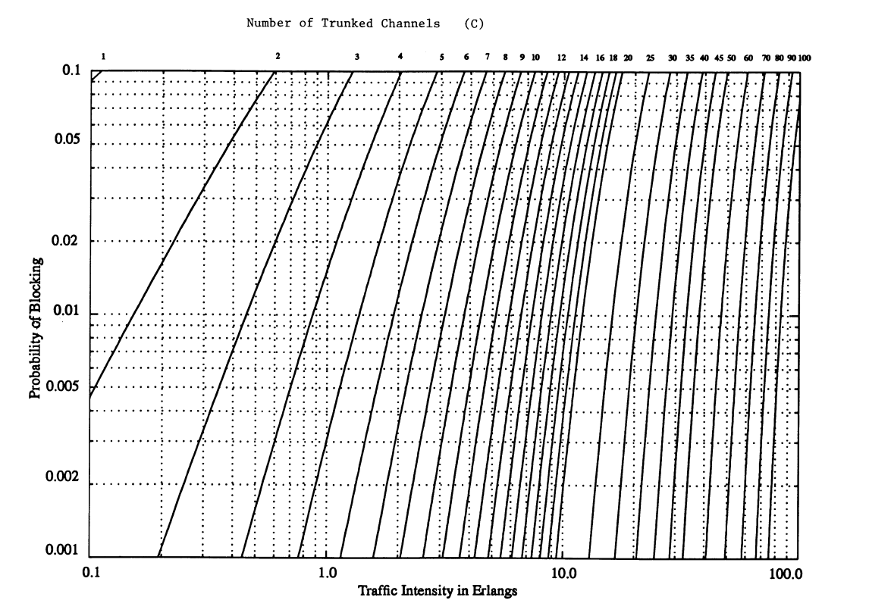

Using this chart, we can use the traffic intensity value (bottom axis) and the number of channels (top axis) to find the probability of blocking.

### Grade of Service

Grade of Service (GOS) is a measure of congestion which is specified as the probability of a call being blocked. It can also be consider the probability of a call being delayed for a certain amount of time, but we will not deal with that.

A GOS of $2\%$ blocking means that $2$ calls out of every $100$ will be blocked during the busiest hour.

### Terminologies

* Set up time – The time required to allocate a trunked radio channel to a user
* Blocked call – A call that cannot be completed due to congestion
* Load – Traffic intensity over the entire trunked radio system
* Traffic intensity – Measure of channel time utilization. It is the average channel occupancy measured in Erlangs. Denoted by $A$.
* Request rate – The average number of call requests per unit time. Denoted by $(λ\sec^{-1}{)}$.
* Holding time – Average duration of a call. Denoted by $H sec$

### Equations

Traffic intensity caused by a single user: $A_{u}=λH$

Total traffic intensity of a system with $U$ users: $A=UA_{u}$

Traffic intensity per channel: $A_{c}=\frac{UA_{u}}{C}$

Erlang B Formula: $\operatorname{Pr}\left[blocking\right]=\frac{\frac{A^{C}}{C!}}{\sum_{k=0}^{C}{\left(\frac{A^{k}}{k!}\right) }}=GOS$

Example

If a service has $50$ channels, how many subscribers can they support at $2\%$ GOS? Assume that the average call holding time is $120s$ and the average busy hour call per subscriber is $1.2$ calls per hour.

From the Erlang B chart, $50$ channels at $2\%$ GOS can support a load of $40.26$ Erlangs.

We are given the average busy hour calls per subscriber. Thus, an individual subscriber’s contribution to the traffic is

$\frac{1.2×120}{3600}=0.04$ Erlang

Thus, the service can support $\frac{40.26}{0.04}=1006.5≈1007$ subscribers.

## 3.7 Improving Coverage and Capacity

As the number of users grow, eventually, the number of channels assigned to a cell will become insufficient. To solve this, we can use a few techniques.

### Cell Splitting

A single cell is subdivided into multiple microcells, each with its own base station with a reduced antenna height and power. Each of the cells reuse the channels available.



Cell splitting increases system capacity and reduces transmission power. However, it also means we need more base stations and that there is more handoff traffic.

### Sectoring

In sectoring, directional antenna are used to divide the cells into sectors. Normally, 3 antennas angled at $120°$ or $6$ angled at $60°$ are used. This causes a decrease in SIR, which in turn means that we can decrease cluster sizes.



Due to the antennas being angled, at $120°$, each antenna is facing rd of the space. This means it can only interfere with $2$ of the $6$ first-tier co-channel cells, thus decreasing interference.

However, since we are dividing channels into sectors, there are fewer trunked channels. Additionally, there will be more handoffs since sectors need to make handoffs too.

### Repeaters

Repeaters are used in hard-to-reach areas, like buildings and tunnels. Upon receiving a signal from the base station, the repeater will amplify the signal and re-radiate it.